The E-Commerce Black Friday

Dear Emily,
I am pleased to announce the upcoming launch of our new, high-performance e-commerce platform, engineered to deliver exceptional reliability and scalability during peak events like Black Friday and beyond.
This cutting-edge system has been designed to support massive demand, handling up to 1 million daily active users and 250,000 concurrent sessions while processing 10,000 transactions per second. Available across web, iOS, and Android platforms, it ensures a seamless shopping experience with fast checkout, real-time order tracking, and robust multi-payment gateway integration featuring automatic failover capabilities.
Security remains at the forefront, with Single Sign-On (SSO), Multi-Factor Authentication (MFA), and full compliance with PCI DSS, GDPR, and CCPA standards. The platform also includes an advanced admin dashboard providing actionable analytics and role-based access controls.
Built for enterprise-grade performance, the system guarantees 99.99% uptime, sub-200ms API response times, and intelligent traffic management during peak loads.
We will share rollout timelines and training opportunities shortly. This represents a major leap forward in our technical capabilities, and I look forward to celebrating this achievement with all of you.
Please, get yourself familiar with system’s Foundation Architecture below in this document.
With any questions feel free to contact me imediately.
Best regards,
Andrei Harhots
Solution Architect | Mphasis Apps BCM Delivery
andrei.harhots@mphasis.com
+(48) 692 040 666
Table of Contents

Requirements 1
Expected Volumes 1
Functional Requirements 1
High-level Architecture Considerations 1
1. Systems and Subsystems Required 1
2. Types of Information Exchanged 3
3. Potential Failure Points 7
Mitigation Actions 7
4. Difference Between Average Load and Peak Load 8
5. Cost-Effective Architecture Decisions 9
6. Security Considerations 10

Requirements
An e-commerce company is launching a new platform to support high-traffic events like Black Friday.
The new system must be resilient scalable and provide seamless transactions.

Expected Volumes
- Expected Daily Active Users: 1 million
- Peak Concurrent users: 250,000
- Transactions per second (TPS): 10,000
- Supported platforms: web, mobile (IOS & Android)

Functional Requirements
- Secure user authentication (SSO, MFA)
- Product catalogue, shopping cart and checkout
- Multiple payment gateway integrations with failover.
- Order tracking, notifications and user reviews.
- Admin dashboard with analytics and role-based access.

High-level Architecture Considerations
- What are the various systems and subsystems required to deliver this functionality?
- What kind of information is exchanged (frequency, speed, volume etc.)?
- What are potential failure points?
- What kind of mitigation actions are necessary to ensure failure preventions
(highlight is as reactive, proactive or preventive)?
- Do you see a difference in the way the system needs to behave during average load and peak load?
- What would you architect for knowing that there can be cost implications?

1. Systems and Subsystems Required
To support a scalable, resilient e-commerce system for Black Friday-level traffic, as an architecture we should include the following modular systems and subsystems:
Core Systems:
- Frontend Platforms
  - Web (React)
  - Mobile Apps (iOS, Android - built with React Native/Flutter)
- Authentication System
  - SSO (OAuth 2.0, OpenID Connect)
  - MFA (TOTP, SMS, Email OTP)
- Product Management
  - Product Catalog Service (with search and filtering)
  - Inventory Management System
- Shopping Cart Service
  - Session-based or user-profile-based carts
  - Cart persistence and sync
- Checkout System
  - Pricing engine, discounts, shipping calculations
- Payment Gateway Integrations
  - Multiple providers (Stripe, PayPal, RazorPay, etc.)
  - Payment Orchestrator with automatic failover
- Order Management System
  - Order lifecycle tracking
  - Fulfillment coordination
- Notification System
  - Email, SMS, Push (via services like Twilio, Firebase)
- User Feedback System
  - Review, rating, and moderation module
- Admin Dashboard
  - Analytics, order stats, user engagement
  - Role-based access control (RBAC)
- Logging & Monitoring
  - Centralized logging (ELK, Datadog)
  - Distributed tracing (OpenTelemetry, Jaeger)
  - Alerts & anomaly detection
- Database Systems
  - Relational DBs for transactions (PostgreSQL, MySQL)
  - NoSQL for product catalog (MongoDB/DynamoDB/Cassandra)
  - Caching layer (Redis, Memcached)
- Infrastructure & DevOps
  - Containerization (Docker, Kubernetes)
  - Auto-scaling (AWS/GCP/Azure)
  - CI/CD pipeline
  - API Gateway, CDN (Cloudflare, Akamai)

2. Types of Information Exchanged
Breakdown of data types, exchange frequency, speed, and volumes:

1. User Authentication & Session Data
- Data Type: JWTs, OAuth tokens, MFA codes, user profiles (PII).
- Frequency: High: 1M+ daily logins (peaking at 250K concurrent).
- Speed: <100ms latency for SSO/MFA flows.
- Volume: ~50KB per session (token + encrypted user data).
2. Product Catalog
- Data Type: Product metadata (names, prices, descriptions), inventory counts, images.
- Frequency: Extreme: 10K+ reads/sec (peaks), writes ~10/sec (admin updates).
- Speed: Cache hits (Redis): <5ms, DB reads (MongoDB): <20ms.
- Volume: ~1TB total (images dominate), cache holds ~10GB hot items.
3. Shopping Cart
- Data Type: Item IDs, quantities, user session IDs.
- Frequency: Spiky: 50K+ updates/sec (add/remove items during peaks).
- Speed: Redis-backed cart: <10ms write latency.
- Volume: ~100MB/sec transient data (ephemeral storage).
4. Checkout & Payments
- Data Type: Order details, payment tokens (PCI-compliant), fraud scores.
- Frequency: Critical: 10K TPS sustained during peaks.
- Speed: Payment processing: 200-500ms (gateway latency).
- Volume: ~1GB/min order data (Cassandra writes).

5. Order Fulfillment
- Data Type: Shipping addresses, tracking IDs, status updates.
- Frequency: Bursty: 5K+ updates/sec (status changes).
- Speed: DB writes: <50ms (Cassandra optimized).
- Volume: ~500MB/hour (logs + DB entries).
6. Notifications
- Data Type: Emails (order confirmations), SMS (OTPs), push notifications.
- Frequency: Async: 50K+ notifications/hour (peaks).
- Speed: Queue processing: <1 sec (Kafka/SQS).
- Volume: ~10MB/min (text-heavy).
7. Analytics & Monitoring
- Data Type: Clickstream data, logs, metrics (CPU, latency).
- Frequency: Continuous: 100K+ events/sec (Prometheus).
- Speed: Near real-time (1-5 sec delay for dashboards).
- Volume: ~10GB/day (compressed logs).
Data Flow Summary
Component | Data Type | Frequency | Speed Requirement | Volume (Peak)
User Auth | Tokens, PII | 1M+/day | <100ms | 50GB/day
Product Catalog | JSON, Images | 10K reads/sec | <20ms (DB) | 1TB storage
Shopping Cart | Session data | 50K updates/sec | <10ms | 100MB/sec transient
Payments | PCI tokens | 10K TPS | <500ms | 1GB/min
Notifications | Emails, SMS | 50K/hour | <1 sec async | 10MB/min
Analytics | Logs, Metrics | 100K events/sec | Near real-time | 10GB/day
Key Challenges & Solutions
- Peak Traffic Handling:
  - Problem: 10K TPS payment processing.
  - Solution: Cassandra (horizontal scaling) + idempotent APIs.
- Low-Latency Reads:
  - Problem: Product catalog access at scale.
  - Solution: Redis cache (95% hit rate).
- Data Compliance:
  - Problem: PCI/PII protection.
  - Solution: Tokenization (Stripe), encryption (AWS KMS).
- Monitoring Overhead:
  - Problem: 100K events/sec logging.
  - Solution: ELK stack with log sampling.
Components and Data Flow Diagram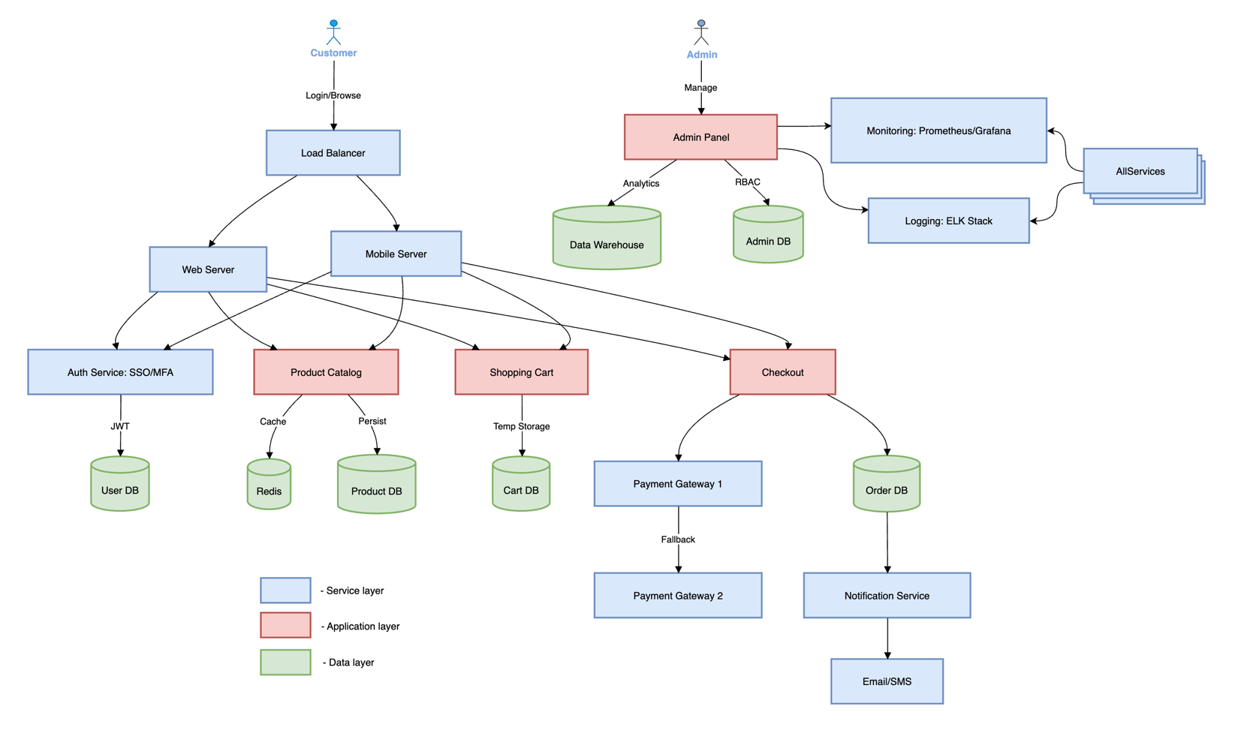
Customers interact via Web/Mobile → Load Balancer distributes traffic.
Auth Service handles SSO/MFA securely.
- Core Features:
- Product Catalog: Cached (Redis) + DB-persisted.
- Shopping Cart: Session storage with auto-expiry.
- Checkout: Connects to Payment Processor with failover.
- Resilience:
- Database Cluster: Master-slave replication.
- Payment Gateways: Fallback mechanism.
- Microservices: Decoupled for scalability.
- Admin & Monitoring:
- Dashboard: Role-based access to analytics.
- Monitoring: Prometheus + ELK for real-time logs.
- Redundancy: All critical components (DB, Payment) have backups.
- Scalability:
- Horizontal Scaling: Stateless services auto-scale.
- Peak Handling: 10K TPS via distributed systems.
- Traffic Spikes: Load balancer + caching handle 250K concurrent users.
- Low Traffic Mode: System scales down 100x via cloud auto-scaling.

3. Potential Failure Points

Component | Failure Scenarios
Authentication | Latency or downtime in SSO or MFA provider
Cart Service | State loss or inconsistency between sessions
Payment Gateway | Gateway downtime or transaction failure
Product Catalog | High latency on DB queries or search index corruption
Order Service | Deadlocks, duplicate orders, stuck order states
Notification Service | Failed delivery, spam filters
Infrastructure/Scaling | Insufficient autoscaling or hitting rate limits
CDN or Cache | Cache miss, stale data, propagation delays
Database | Connection saturation, slow queries
Admin Dashboard | Incorrect role access or slow analytics queries

Elaborated failure points
Critical potential failure points:

1. Payment Gateway Failures
- Risk: Primary payment processor (e.g., Stripe) goes down during peak traffic.
- Mitigation:
  - Automated failover to secondary gateway (e.g., PayPal/Braintree).
  - Idempotent requests to prevent duplicate charges during retries.
  - Circuit breakers to halt requests after N failures.

2. Database Bottlenecks
- Risk:
  - Product DB: Sharded MongoDB hits write limits during flash sales.
  - Order DB: Cassandra cluster overloaded at 10K TPS.
- Mitigation:
  - Read replicas for MongoDB (scale reads).
  - Rate limiting at API layer to throttle non-critical writes.
  - Pre-warming Cassandra nodes before Black Friday.

3. Cache Stampede
- Risk: Redis cache expires for hot products (e.g., 50K requests hit DB simultaneously).
- Mitigation:
  - Cache warming: Pre-load top 1% products before peaks.
  - Probabilistic early expiration: Renew cache before TTL ends.
  - Local caching: Use CDN for static product data.

4. Auto-Scaling Lag
- Risk: Web tier takes 2–5 minutes to scale out during traffic spikes.
- Mitigation:
  - Predictive scaling: Trigger scale-out based on traffic forecasts.
  - Pre-provisioned "warm" instances in standby pool.

5. Fraud False Positives
- Risk: Fraud detection system blocks legitimate high-volume buyers.
- Mitigation:
  - Human-in-the-loop for high-value orders.
  - Dynamic rules: Adjust thresholds during peak events.

6. Third-Party API Downtime
- Risk: SMS/email providers (e.g., Twilio/SendGrid) fail, delaying notifications.
- Mitigation:
  - Queue-and-retry: Use Kafka/SQS to buffer messages.
  - Multi-provider fallback (e.g., AWS SES + SendGrid).

7. Thundering Herd Problem
- Risk: 250K users refresh product pages simultaneously after restock.
- Mitigation:
  - Exponential backoff in client retries.
  - Edge caching: Serve stale product data for 5s during updates.

8. Monitoring Blind Spots
- Risk: Metrics delay (e.g., Prometheus scrapes every 15s) hides real-time failures.
- Mitigation:
  - Real-time streaming (e.g., AWS Kinesis + Lambda alerts).
  - Synthetic transactions: Simulate user flows every 30s.

9. Container Orchestration Failures
- Risk: Kubernetes control plane crashes under load.
- Mitigation:
  - Multi-AZ deployments for etcd cluster.
  - Pod anti-affinity rules to prevent single-node bottlenecks.

10. Data Corruption
- Risk: Order DB (Cassandra) loses writes during network partitions.
- Mitigation:
  - Quorum consistency (LOCAL_QUORUM for writes/reads).
  - Cross-region backups every 5 minutes.

Failure Scenario Playbook
Scenario | Detection | Resolution
Payment gateway timeout | HTTP 503 alerts | Auto-failover to backup provider
Redis OOM | Memory usage >90% | Scale cache cluster + evict cold keys
Checkout API latency spike | P99 > 1s for 2 minutes | Scale out checkout service pods
DB CPU saturation | CloudWatch alarms | Redirect reads to replicas

Key Takeaways
- Design for Redundancy: Every critical path (payments, DBs) needs a failover.
- Test Chaos Engineering: Simulate failures (e.g., kill Cassandra nodes) pre-peak.
- Monitor Everything: Even "minor" services (e.g., SMS) can cascade into outages.

Mitigation Actions

Component | Action Type | Mitigation
Auth & MFA | Proactive | Use redundant auth providers, fallback MFA methods
Payment Gateway | Reactive | Retry logic, auto-failover between gateways
Caching Layer | Preventive | Warm up cache, lazy loading strategies
Database | Preventive | Query optimization, read replicas, sharding
Cart & Checkout | Proactive | Session stickiness, service retries
Infrastructure | Preventive | Auto-scaling, chaos testing
Notification | Reactive | Retry queues, dead-letter handling
Monitoring | Proactive | Real-time alerts, dashboards for ops team
System Updates | Preventive | Canary deployments, blue-green deployments

4. Difference Between Average Load and Peak Load
Yes, the system must handle drastic behavioral shifts during peak load:
Aspect | Average Load | Peak Load (Black Friday)
Traffic volume | Moderate & predictable | Sudden spikes, high concurrency
Resource allocation | Minimum instances auto-scaled | Pre-warmed resources, over-provisioned buffers
Caching | Normal cache usage | Cache hit ratio must be near 100%
Queues & Async ops | Lower throughput | High throughput, resilient queuing
Monitoring | Lower priority alerts | Aggressive real-time monitoring
Rate-limiting | Basic controls | Strict rate limits to prevent overload
Feature toggles | Full features | Might disable less-critical features (e.g., reviews)

Deployment Diagram
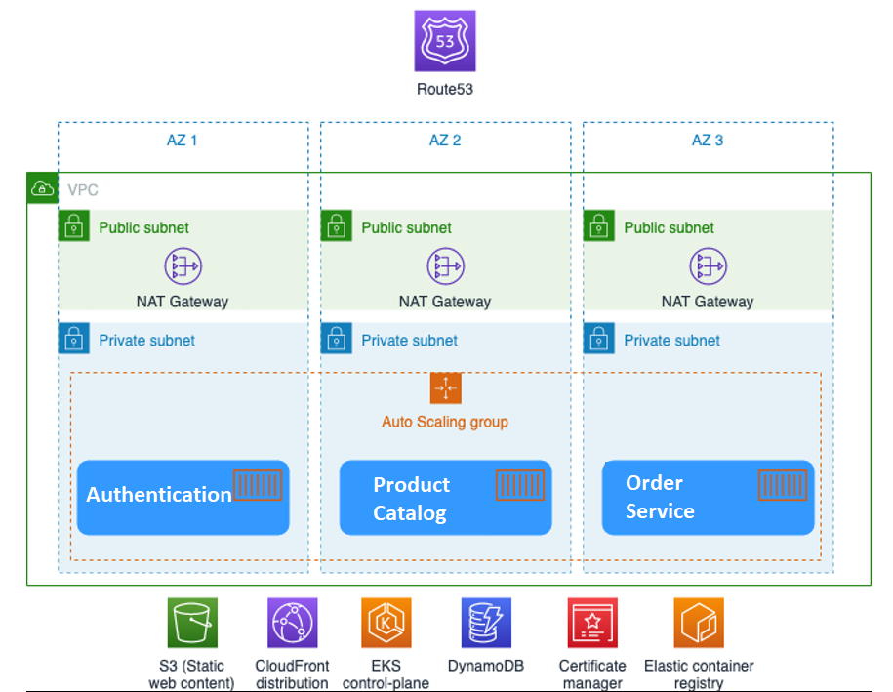

5. Cost-Effective Architecture Decisions
Given cost constraints, focus on balancing performance and cost:
Smart Choices:
- Use serverless components (e.g., AWS Lambda, Firebase Functions) for bursty workloads (e.g., notifications).
- Cache everything: Use CDN + Redis for product listings, static assets, and cart items.
- Use message queues (Kafka, SQS) for async and retriable tasks like notifications and order processing.
- Employ multi-tier storage: Premium SSD for transactional DBs, cheaper blob storage for logs/media.
- Auto-scaling Kubernetes or ECS clusters—scale-to-zero where possible.
- Leverage spot instances or reserved instances for predictable workloads.
- Integrate feature flags to gracefully degrade non-essential services during high load.

6. Security Considerations
Here are the critical security considerations for your high-traffic e-commerce system, designed to handle Black Friday-scale loads while protecting data and ensuring compliance:
1. Infrastructure Security
DDoS Protection:
- Use AWS Shield/Cloudflare to mitigate volumetric attacks during peak traffic.
- Deploy rate limiting (e.g., 10,000 TPS per IP).
Network Segmentation:
- Isolate public-facing servers (web/mobile) from internal services (DBs, payment) using VPCs/NACLs.
WAF (Web Application Firewall):
- Block SQLi, XSS, and bot traffic (e.g., AWS WAF with OWASP rules).

2. Data Security
Encryption:
- In Transit: TLS 1.3 for all communications (HTTPS, API calls).
- At Rest: AES-256 for databases (e.g., PostgreSQL, Cassandra).
PCI DSS Compliance:
- Tokenize credit card data; never store raw PANs. Use PCI-compliant gateways (Stripe, PayPal).
Data Masking:
- Anonymize PII in logs/analytics (e.g., replace emails with hashes).

3. Authentication & Access Control
Multi-Factor Authentication (MFA):
- Enforce MFA for admin dashboards and sensitive operations (e.g., refunds).
- Role-Based Access Control (RBAC):
- Limit admin access (e.g., "read-only" for support staff).
Session Management:
- Short-lived JWT tokens (15–30 mins) with Redis-backed revocation.

4. Payment Security
Payment Gateway Failover:
- Use certified providers (Stripe + Braintree) with automatic fallback.
Fraud Detection:
- Integrate tools like Signifyd or Kount for real-time fraud scoring.
Idempotency Keys:
- Prevent duplicate charges during retries (critical for 10K TPS).

5. API Security
OAuth 2.0/OpenID Connect:
- Secure mobile/third-party API access with scoped permissions.
API Rate Limiting:
- Throttle non-critical endpoints (e.g., product reviews) during peaks.

6. Monitoring & Incident Response
Real-Time Alerts:
- Monitor for anomalies (e.g., 500% spike in failed logins).
Audit Logs:
- Track all admin actions (who deleted a product?).
- Automated Responses:
- Auto-block IPs after 10 failed auth attempts.

7. Compliance & Legal
GDPR/CCPA:
- User data deletion workflows. Cookie consent banners.
SOC 2 Type II:
- Required if handling enterprise customers.

8. Scalability-Specific Risks
Cache Poisoning:
- Sanitize keys in Redis (e.g., user input as cache keys).
Database NoSQL Injection:
- Validate inputs for MongoDB/Cassandra queries.
Auto-Scaling Misconfigs:
- Ensure new instances boot with hardened AMIs/containers.
Implementation Checklist:
- Enable DDoS protection (AWS Shield/Cloudflare).
- Encrypt all databases (AWS KMS/HashiCorp Vault).
- Tokenize payments via Stripe/Braintree.
- Deploy WAF with OWASP Core Rule Set.
- Test failover for payment gateways.
- Schedule quarterly penetration tests.

Example Attack Mitigations
Threat Solution
Card skimming PCI DSS + iFrame embeds (Stripe.js)
Credential stuffing MFA + CAPTCHA for >5 failed logins
Inventory hoarding bots Rate limit "Add to Cart" API calls

Security Diagram

